2020-2025
STRATEGIC PLAN

MAYSVILLE PUBLIC SCHOOLS

MAYSVILLE, OKLAHOMA

__________________________ ___________________
WHERE YOUR CHILD GAINS A FAMILY!

Reviewed July, 2023

Maysville School District continually strives to meet the needs of each and every student within the district. The district partners with community organizations, businesses and patrons to ensure all students are preparing for future success.

Through collaboration among stakeholders over a span of several months, the district’s strategic plan was developed. This document envisions the future of Maysville Public School. School board members, administrators, teachers, students, staff and community leaders studied the current state of the district, identified areas of focus and developed goals to strive towards.

I am greatly appreciative of the time, energy, hard work and creativity given by many in the development of the Maysville Strategic Plan. This plan is our guide to reference as we continue to prepare our students for future success.

Dr. Shelly H-Beach
Superintendent

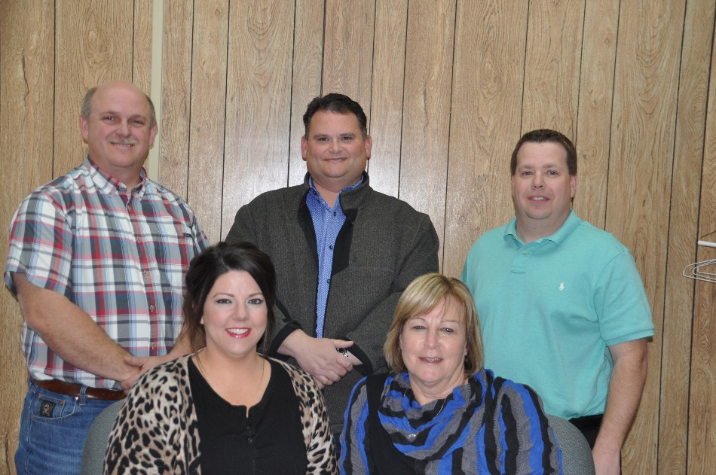

Board of
Education

Rodney Townley President

David Klein Vice-President

Heidi Gamble Clerk

John Williams Member

Cindy Wilmot Member

STRATEGIC PLANNING
TEAM MEMBERS

Kimberly Layton David Klein Krysti Kesler

Vickie Foraker Mike Deviney Jenni Arnold

Kristy McGowen Tresa Hackney Rochelle Ward

Kirk McGowen Asheley Close Tyler Dean

Jaci McGowen Dace Lemieux Rhonda Brown

John Williams John Edwards Cherye Davis

Brittany Morphew Deb Degering Amber Wigley

Heather Ivey Kim Best Marissa Moates

Dr. Shelly Beach

DISTRICT
PROFILE
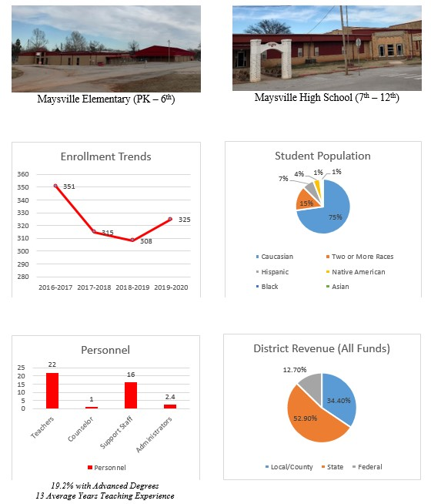

Executive
Summary

Maysville Public Schools’ 2020-2025 Strategic Plan is recognized as a guide to direct the advancements impacting student success. The plan focuses on academics, district personnel and facilities, and community relations. To enable students to be college and career ready, all students will be exposed to rigorous academic standards. Teachers will participate in high quality professional development that supports student growth and meets the diverse needs of all students.

The district recognizes the need to have secure and safe facilities for all students and staff. Within the plan are steps to secure a FEMA rated facility to be used by the community as well. Community and parent partnerships are foundational to the success of the district. By increasing community involvement opportunities and recognition events, the district will strengthen the unity found within our community

The plan will be a guide to use during the development of individual campus goals and strategic plans. The initiatives and action steps will be regularly monitored and the Board of Education will be updated periodically. The plan sets the expectations for the next five years of the district. All students regardless of ethnicity, language, disability or income level can achieve high standards of learning. Maysville students will meet and/or exceed the state standards and graduate being career or college ready.

District Vision

Maysville Public School is committed to help each student reach their full potential while developing their pride in self, school and community.

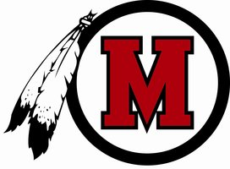

District Mission

The Maysville Board of Education believes that each student has a right and responsibility to succeed, to achieve to the limit of his or her ability and to take pride in his or her achievements.

Every student will be guided firmly, but with kindness and impartiality, while being able to demonstrate pride, respect and dignity in their self and community.

The board recognizes that achievement of educational excellence is a joint effort of the school, the home and the community.

The board believes that each student will graduate with marketable skills and a solid foundation upon which future skills can be built.

Core Values

RESPECT
PRIDE
HONESTY
WORK ETHIC
SAFE ENVIRONMENT
QUALITY EDUCATION

District Goals

Academic Focus

- To align vertically elementary and high school standards so that transition from one grade to the next is easier.
- To increase instructional rigor and student’s depth of knowledge.
- Teacher directed professional development to help meet the diverse needs of students. Professional development geared towards helping teachers guide students through their educational endeavors; guiding them to be problem solvers and critical thinkers.

District Focus

- Fall of 2020, present a bond proposal to Maysville Public School patrons to construct a facility for students incorporating safe room designs for all student enrollment and community use.
- Focus on enhancing security measures and training opportunities for staff to prepare for emergencies.
- Identify available resources to provide remediation opportunities for students in need.

Community Focus

- Increase community involvement and satisfaction through outreach and community communication.
- Increase school and student involvement in the community through giving back to the community members.
- Increase school and community spirit by involving the two groups’ attributes in conjunction with one another.

Academic Focus - District Goals

- To align vertically elementary and high school standards so that transition from one grade to the next is easier.

- The site principals will periodically coordinate shared planning times for district teachers to meet, plan, coordinate and review district curriculum.
- During these time, teacher teams will use the state academic standards as the guide to ensure a seamless transition from one grade to another occurs.
- A review of state assessment results will determine the progress of the teams by identifying any additional gaps based upon student performance.
- The goal of the plan is to improve student performance by 2% each year.

- To increase instructional rigor and student’s depth of knowledge.

- The site principals will periodically coordinate shared planning times for district teachers to meet, plan, coordinate and review district curriculum.
- During these times, teacher teams will use the state academic standards as the guide to determine the required rigor and depth of knowledge needed for students to master the standard.
- Course curriculum will be evaluated by comparing it to the standards and identify any weaknesses that may be present.
- A review of the state assessment results will determine the progress of the teams by identifying the level of mastery based upon student performance.
- The goal of the plan is to improve student performance by 2% each year.

- Teacher directed professional development to help meet the diverse needs of students. Professional development geared towards helping teachers guide students through their educational endeavors; guiding them to be problem solvers and critical thinkers.

- The site principals will survey the professional development needs of their teachers.
- Based upon the observations of student performance, the teachers will self-assess their specific needs to enhance their professional growth.
- The professional development days will be designed to address the majority of the needs identified by the surveys.
- A self-assessment will be used at the end of the year to identify whether the specifically designed professional development enhanced professional growth.
- The goal of the plan is to continue specifically designed professional development that enhances the overall social, emotional and academic success of students.

District Focus - District Goals

- Fall of 2020, present a bond proposal to Maysville Public School patrons to construct a facility for students incorporating safe room designs for all student enrollment and community use.

- By the end of Spring 2020, the district administration will have drafted plans for a new construction project and submit the project design in a FEMA grant application.
- The construction project will be FEMA rated for student and community access during violent weather conditions.
- To maximizes funds, a bond proposal will be voted on to fund the remaining construction cost not paid for by a FEMA grant.
- The goal of the plan is to erect a FEMA rated structure on the elementary campus in the near future.

- Focus on enhancing security measures and training opportunities for staff to prepare for emergencies.

- Each year the site principals will identify campus security needs to ensure the safety of students and staff.
- Funding opportunities will be pursued to provide the identified needs of each campus.
- Through a survey of the staff, necessary professional development focused on emergency preparedness will be identified and training opportunities planned.
- The professional development will be scheduled during the district’s in-service or built-in professional development days throughout the school year.
- The goal of the plan is to ensure the safety of all students and staff.

- Identify available resources to provide remediation opportunities for students in need.

- As academic weaknesses are identified, district administration will design budgets to include remediation strategies.
- Local, federal and grant revenue sources will be used to fund remediation opportunities for students on a yearly basis.
- Through site meetings and professional learning community dialogue in the spring of each school year, the desired remediation strategies for future implementation will be located and cost identified to assist with developing the yearly budget.
- The goal of the plan is to boost the academic performance of the bottom quartile by 2%.

Community Focus - District Goals

- Increase community involvement and satisfaction through outreach and communication.

- At the beginning of each year, the district administration and staff will identify opportunities to connect with the community.
- Events on-campus and off-campus will be listed and organizations will be earmarked to lead the events.
- The district’s messaging system and website will be utilized to communicate with families and patrons promoting school events.
- The goal of the plan is to increase the positive relationship between the school district and the community.

- Increase school and student involvement in the community through giving back to the community members.

- Organizations will be challenged to identify a service learning project at the beginning of each year.
- By completing the projects, school and student involvement in the community will increase.
- The high school counselor will keep record of student participation as the students submit their community service forms each year.
- The students will be able to identify their service participation on college applications and scholarships to enhance their college and career readiness.
- The goal of the plan is to build a sense of community pride among the students.

- Increase school and community spirit by involving the two groups attributes in conjunction with one another.

- Each year, the district administration will identify ways to connect the school to the community, either through service projects or school events.
- By examining the yearly school events, the administration will incorporate strategies to connect with the community. For example, the yearly homecoming parade will invite three alumni classes to enter a float to be judged. This activity will bring a sense of community, connection, and spirit while increasing participation and interest in the parade. This in turn will provide local businesses increased revenue and the city additional tax funds.
- The goal of the plan is to boost the Warrior pride among all community members.

Acknowledgements

Maysville Public School would like to recognize the hard work of the Strategic Planning Committee members. The monthly participation provided a wealth of knowledge and developed stronger partnerships across the community. This plan will be distributed to the Committee members, shared with the faculty and staff and available on the district website. A yearly review of the plan will be conducted to ensure the district is pursuing the achievement of the identified goals. By investing in Maysville student’s, the district will succeed.

Thank you to all involved in this year long process. The district’s motto is the connection among everyone, “Where Your Child Gains a Family!”

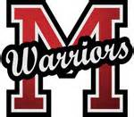

JULY 2021 REVIEW

Academic Focus - District Goals

- Professional Learning Communities (PLCs) implemented at HS in 20-21; Common plan for PLC implementation at elementary for the 21-22 school year – PLCs used to address curriculum and identify weakness and develop strategies for success

- PLCs reviewed student assessment data to identify weaknesses and design rigorous lessons, NO state assessments for Spring 2020 due to COVID, used on-site student assessments; District investment in curriculum resources: textbooks & online platforms

- Through online PD platforms, staff have the choice on the courses they are interested in completing; during staff meetings, PD needs are identified and planned accordingly

District Focus - District Goals

- Due to delay with county mitigation plan, the FEMA grant is on hold. Therefore, bond proposal items changed to renovate bathrooms for ADA accessibility, purchase new band uniforms, replace outdated scoreboards and install an all-weather track. Bond will be voted on in September 2021.

- Through federal COVID relief funds, security cameras will be installed on both campuses. Spring 2021, PD will be provided by the Garvin County Emergency Management service on responding to emergencies on campus.

- Using federal COVID relief funds, tutoring will be provided after school to any student. At the elementary campus, extra reading instruction is provided to students who are identified at being at-risk at not passing state assessments.

Community Focus - District Goals

- During 20-21, COVID shut down on-campus events; however, through the district communication app information was provided to inform the community about numerous events, activities, date changes, etc. For the 21-22 school year, the federal programs committee will establish parental involvement activities to conduct.

- Both sites will identify activities organizations will participate with to “give back” to the community.

- For the homecoming parade, invitations will be solicited for alumni to participate with a float. Now that COVID restrictions are lifted, volunteers will be encouraged for on-campus events. Organizations can now determine what activities they will be involved in to provide a service to the community.

JULY 2022 REVIEW

Academic Focus - District Goals

- Professional Learning Communities (PLCs) implemented at HS in 20-21; Common plan for PLC implementation at elementary in 21-22 – PLCs used to address curriculum and identify weakness and develop strategies for success. Math curriculum was vertically aligned and curriculum maps developed during 21-22.

- PLCs reviewed student assessment data. STAR assessment reports reviewed along with Spring 21 state assessment data. Spring 21 assessments will be used as a base line.

- Through online PD platforms, staff have the choice on the courses they are interested in completing; during staff meetings, PD needs are identified and planned accordingly

District Focus - District Goals

- Construction Bond approved Fall 2021, new all weather track, ADA athletic bathrooms, band uniforms, new outdoor scoreboards are currently in the process of completion.

- Security cameras installed on both campuses. Partnership with the Oklahoma School Security Institute develop to identify needed improvements in security measures. PD scheduled for Fall 2022 In-Service on responding to emergencies.

- Tutoring offered at both sites afterschool paid through COVID funds.

Community Focus - District Goals

- For 21-22, several after-hour events were held that allowed parental involvement.

- Community Service events occurred several times throughout 21-22, ie. Senior Citizen dinners, Chamber of Commerce community assistance.

- For the homecoming parade, invitations will be solicited for alumni to participate with a float. Volunteer background checks implemented and several community members provided valuable hours of support.

JULY 2023 REVIEW

Academic Focus - District Goals

- District math teachers continued to meet to ensure curriculum alignment and implement remediation opportunities.

- ELA initiatives to increase rigor were implemented at the elementary as well as remediation opportunities.

- Leadership teams and PLCs influenced the professional development sessions to support SPED modification/accommodation struggles and to introduce Universal Design for Learning (UDL) strategies.

District Focus - District Goals

- Continued discussion occurred with the Garvin County Emergency Management division regarding the county mitigation plan. The mitigation plan is needed to complete a FEMA grant application to assist with funding a safe room due to cost.

- Secured a Stronger Connections grant to provide a district Resource Officer for the next three years. Additional security cameras were installed.

- Supplemental online programs and tutoring were provided for remediation opportunities.

Community Focus - District Goals

- Partnerships with the Red Hatters provided testing monitors and 4H program assistance. The elementary pumpkin patch brought several community members and organizations together.

- Through sponsor led activities, students were involved in several activities that gave back to the community and county. Food drives, sock drives, DHS baby item drives, dinners, military supply drive, senior citizen center and blessing box contributions.

- Meet the Warriors took place in the grove and had a great turn out, elementary fall carnival, homecoming parade, and the basketball alumni game were great ways to enhance school pride and school spirit.

